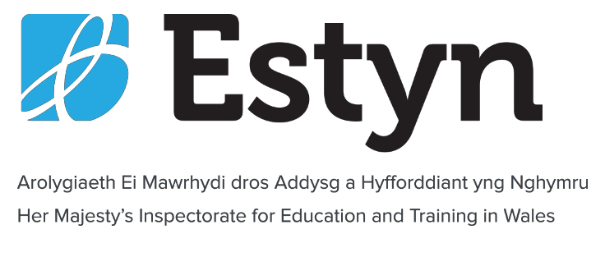

Initial Contact Form

ESTYN SAFEGUARDING INITIAL CONTACT FORM CONFIDENTIAL
The following information is CONFIDENTIAL. However, where relevant, information may be shared with other agencies such as the police and social services. Some aspects may also be shared with local authority education services
Date of referral:
Informant’s details
Name of the informant/caller:
Telephone number of informant /caller :
Address of informant/caller:

Child’s, young person’s or vulnerable adult’s details
Full name of child, young person or vulnerable adult :
Date of birth if known:
Address if known:
Place where the alleged issues took place
Name and address of the education provider concerned:
Where the alleged incident/s took place:
When the alleged incident/s occurred:
If the disclosure has been made while on inspection has the providers’ safeguarding officer been informed?:
If yes please give their name and contact details

Broad nature of the concern
e.g. bullying; abuse by professional; poor handling of safeguarding issues
The information below may be shared with the police and/or social services, and therefore cannot be confidential. However, is there any of the information below the informant may prefer to be shared only with Estyn, the Police and local authority social services? :
Name of person completing this form:
Date referred and to whom:
Date uploaded to safeguarding log:

Contact details for all referrals

Contact details for Estyn’s designated safeguarding officers:
Safeguarding officers
Lead safeguarding officer 02920 446482 (24 hrs)
Deputy safeguarding officer 02920 446484 (24 hrs)
Estyn Office: 02920 446446 (office hours only) Anchor Court, Keen Road Cardiff
Email: safeguarding@estyn.gov.uk
Social services duty officer telephone contacts for safeguarding referrals for children or vulnerable adults (all details updated September 2014)

County | Child referrals | Adult referrals | Out of hours if different | Designated Lead Officer – Safeguarding in Education
Blaenau Gwent | 01495 315700 | 01495 315700 | 0800 328 4432 | Sarah Dixon 01495 356 016
Bridgend | 01656 642320 | 01656 642353 | 01443 734 665 | Laura Kinsey 01656 642 314
Caerphilly | 0808 1001727 | 0808 1002500 | 0800 328 4432 | Jackie Garland 01443 866651  Helen West 01443 866643
Cardiff | 02920 536490 | 02920 243 234  (also adult out- of-hours) | 02920 788570  (children) | Andrea Mazloom 029 22 330879  Carol.Jones2@c ardiff.gov.uk
Carmarthenshire | 01554 742 322 | 01558 825 371  + 01267  228944 | 01558 824 283 | Rebecca Copp 01267 246 595
Ceredigion | 01545 574000 | 01545 574000 | 0845 6015392 | Sarah Llewelyn 01970 633 624
Conwy | 01492 575111 | 01492 576333 | 01492 515 777 | Sian Pineau 01492 575 036
Denbighshire | 01824 712200 | 03004 561000 | 0845 053 3116 | Wayne Wheatley 01824 708 169
Flintshire | 01352 701000 | 01352 803444 | 0345 0533116 | Dave Messum 01352704122,  07796996901

County | Child referrals | Adult referrals | Out of hours if different | Designated Lead Officer – Safeguarding in Education
Gwynedd | 01758 704455 | 01286 682888 | 01286 675 502 | Ffion Eleri Rhisiart  01286 679 007
Isle of Anglesey; Ynys Môn | 01248 752733 | 01248 752752 | 01286 675 502 | Jane Marr 01248 752 936  01407 767 782
Merthyr Tydfil | 01685 725 000 | 01685 725 000 | 01443 743665 | Sarah Bowen 01685 725 082
Monmouthshire | 01291 635669 | Caldicot/Chepsto w 01291  635666  Monmoth/Usk/Ra glan  01600 773041  Abergavenny  01873 735885 | 0800 328 4432 | Heather Heaney 01633 644 392  07917 707343
Neath Port Talbot | 01639 686803 | 01639 686802 | 01639 895 455 | Christopher Millis 01639 763 226  Amanda Hinton 01639 763 363
Newport | 01633 851423 | 01633 656656 | 0800 328 4432 | Nicola Davies 01633 235664
Pembrokeshire | 01437 764551  Martin Reynolds 01437 776 688 | 01437 764551  Karen Panter 01437 776 330 | 08708 509 508 | Cheryl Loughlin 01437 776 549
Powys | 01597 827 666 | 01597 827 666 | 0845 757 3818 | Keith Brelstaff – 01597 82 6448  Sue Morgan 01597 827 099
Rhondda Cynon Taff | 01443 742 928  Debbi Davies 01443 742 927 | 01443 742 940 | 01443 743 665 | Sue Walker 01443 744 005
Swansea | 01792 635700 | 01792 636519 | 01792 775501 | Paul Henwood 01792 637 148

Torfaen | 01633 647249 | 01633 647248 | 0800 328 4432 | Darren Joseph 01495 766 932
Vale of Glamorgan | 01446 725202 | 01446 700111 | 02920 788570 | Dorian Davies 01446 709 867
Wrexham | 01978 292039 | 01978 292066 | 0345 0533116 | John Grant 01978 295 418  01978 268 165

Other helpful numbers
Childline UK 0800 1111
NSPCC Help and advice 0808 800 5000

CSSIW contact details
National Office contact details 0300 7900 126
Follow the key pad hints for regional offices.
The link below provides contact details for CSSIW regional offices: https://cssiw.gov.wales/contactus/?lang=en

